Grade 5
Pinball Game

Description: | Students will:  Create a pinball game.  Create variables for speed and score.  Use keyboard input test to control the flipper motion;  Write conditional statements controlling the direction the pinball will bounce and when the score will change.  Use x and y grid coordinates to position game pieces.  Make a reset script.  Make a title, a flap and game directions.
Project View | 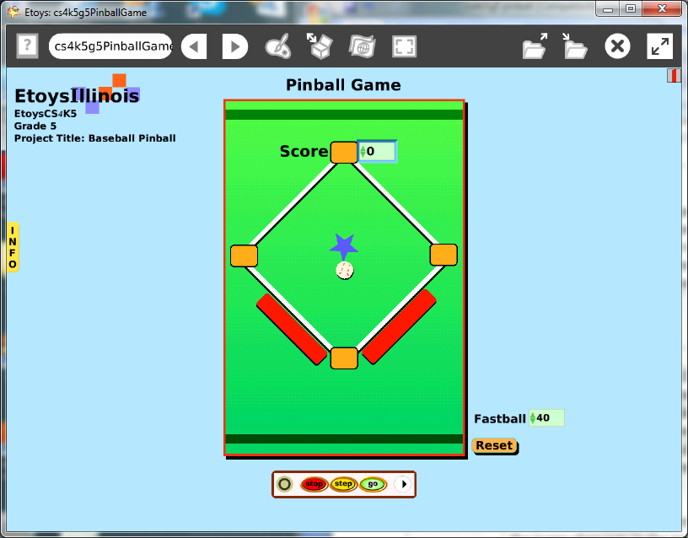
Subject: | Math
Etoys Quick Guides | Click the question mark in Etoys to open the set of interactive tutorials for basic tools and techniques.
Vocabulary: | Variables, conditional statements, variables, random number generators, angles, degrees, X/Y coordinate points on the plane, heading, decimals, increase/decrease, positive and negative values
Lesson 1:  Paint Tools: Brushes  Paint Tools: Straight Line Tool  Script Tiles: Forward by  Script Tiles: Bounce  Script Tiles: Tests  Script Tiles: Random Numbers  Navigator Bar: Keep Find | These lessons are numbered but a lesson may take several class sessions to accomplish. Lesson 2 does not mean Day 2.  Give students time to build the many elements in the game, to make decisions about the action in their game, how to control play and to script what they want to happen, when, and where.  Discuss the elements of a pinball game (virtual or real) that students have seen or played.  Give students time to plan their game: theme, colors, shape and style of action pieces, scoring, penalties, and control mechanisms.  This example has a baseball, bases, and flippers on a playfield.  Paint a baseball. It is good practice to name objects and scripts as they are made.  Paint a flipper and make a copy.  Paint a base and make three copies.  The baseball has one script controlling the basic motion and the interactions with the flipper and bases.  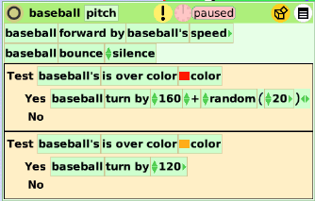  Give students time to experiment with the turn by angles. This time is when students build a vocabulary of ideas built on specific examples that work or don’t work in their project. Discuss the purpose of the random number tile and how their project is affected by it. Discuss the range of random number added to their project.  Keep the project. Name it: NamePinball, e.g. KatePinball
Lesson 2:  Halo Handles: Center of Rotation  Menu Tools: Viewer Icons | Make a script for a flipper that uses keyboard input.  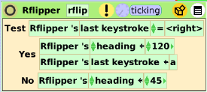  Move the center of rotation to the pivot end of the flipper.  Discuss the effect of moving the flipper’s center of rotation. Remind students that the center of rotation does not have to be on the object, it can be somewhere else. Experiment. Discuss.  Experiment with the headings. The difference between the two heading values is the amount of action. Students need time to decide how big or small the action will be and what is best for their game plans.  If the results are too predictable and students want to introduce more chance into their project, use a random number generator tile found in the gold box in the top border of the Scriptor.  When the action is correct, copy the flipper and modify the script headings. The left flipper in the example project uses negative numbers for the headings.  Keep the project.
Lesson 3:  Menus: Viewer Icons Set  Script Tiles: Hide Show | Make a variable for the pinball and name it speed. Put a detailed watcher on the game board for the player to use.  Draw or type a phrase to show at the end of the game such as: you win or game over.  Decide when the game is over and make a script.  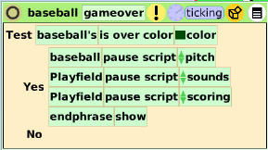  Give students time to try other student’s projects and discuss what they see and how it works. Give them time to modify their project again.  Keep the project.
Lesson 4:  Halo Handles:  Viewer  Script Tiles:  Scale Factor  Script Tiles:  X and Y  Menu: Drop Shadow  Menus: Painting | Give students time to develop the theme of their pinball game. This one is a baseball game.  Give students time to create the graphics for their game. They may decide to change the appearance of the flippers or game ball as their ideas develop for the other objects.  Change the color of the world: use the fill and border category tiles if gradient color shading is desired.  Get a playfield from Supplies and modify its color and border too. The playfield will contain the action of the game.  Students should put their game pieces on into position and modify the scale of objects using the scale factor tile in the geometry category in the Viewer.  Encourage them to use the tile rather than the yellow halo handle because they can set the size precisely, control the amount of change, and can undo and redo easily with the numbers.  Set exact positions of all objects using their x and y axis tiles. These adjustments can be made with the tiles still in the viewer. Plan starting positions and game end positions.  Add drop shadows to game pieces. Discuss what kind of rule the shadows should follow. Ask: where is the light source/how does that affect where the shadow would be? Discuss.  Give students time to modify the appearance of objects they have scripted already.  The white menu includes an option in the painting list to add a border around the object. Some students will like this graphic effect, give them time to experiment with these effects.  Keep the project.
Lesson 5:  Script Tiles: Test Category  Menu: Watchers | Create variable called Score for the Playfield.  This variable is used in tests that determine when the score will increase and/or decrease. The examples below show decisions of this game maker. Decisions will need to be made by students so that their game plays the way they want.  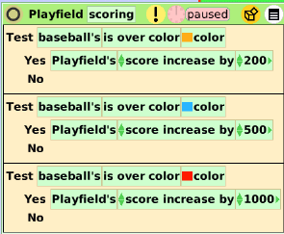  Use a detailed watcher to show the score during the play of the game.  Keep the project.
Lesson 6:  Script Tiles: Sound Category | Make a script that adds sounds to the game pieces that increase and decrease the score. Sounds can also be added when the object bounces on the edges of the playfield.  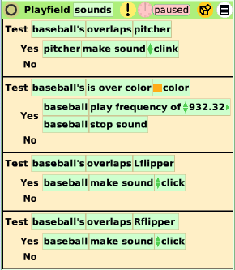  The sound category of tiles lets students specify the exact pitch they want to associate with each object. They might like to do a little research to find out what Hz to chose for specific pitches that make a major or minor scale.  Keep the project.
Lesson 7:  Menu: Button Fires a Script  Supplies: Text | Make a reset script for all the objects that move or change in the game.  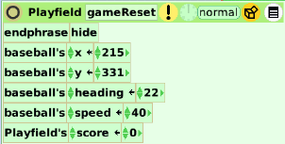  Modify the button, color, size, text and location.  Give students time to make changes, to experiment with choices, and to adjust the action of their game and the graphics.  Give students time to watch while other students play their game and then discuss how it plays when used by someone unfamiliar with that game and to see if the game is playable by someone they will never meet and can not advice except through the material they provide.  Students should title their game and write rules and other information for the player.  Students should decide how resistant to change the pieces will be. The white menu in the halo of every object includes resist being picked up and be locked.  Final checks include evaluating appearance, spelling, and removing trash cans and other authoring tools. Close all the viewers.  Change the name of the finished project: namePinballFinal.
Standards: | Common Core Standards  Mathematics: 5.NBT.3; 5.NF.5.6; 5.G.1.2  Bloom’s Taxonomy/Cognitive Domain:  Knowledge: describes, selects  Comprehension: estimates, explains  Application: produces, uses  Analysis: analyzes, compares  Evaluation: compares  NETS  1. a, b, c  3. a, b  4. b
Resources: | Etoys Help Quick Guides: always available in Etoys. Open Etoys and click the question mark to open a set of interactive tutorials of basic tools and techniques.  www.etoysillinois.org projects, lesson plans, software download  www.mste.Illinois.org more math, science, and technology resources  www.corestandards.org Common Core Standards  www.squeakland.org software and Etoys projects  www.nctm.org Standards and Focal Points for each grade level
kh January 2011

